# **YOU HAVE A WHOLE TAB MISSING !!!**

# **Customize ( will be a tab ; add it after Portfolio)**

EDI welcomes the customized construction template , first in service , first of its type in the country, where you can select each of the construction materials which you want us to use for the construction of your dream project. Shake hands with us and Let us build your Project with your choice of materials.

This will have the following details with Drop down menu made available for every item :

1. Exterior Wall Material - [ Brick Masonry , AAC Blocks , Other - Describe (space for text)]
2. Partition Wall Materials - [ Same choices from above + Cement Board Panels ]
3. Reinforcement Bars - [ Panchakanya , Himal , Hama , Jagdamba , Other - Describe]
4. Cement - [ Shivam OPC , Shivam PPC , Maruti OPC, Maruti PPC , Hetauda OPC , Hetauda PPC , Other - Describe ]
5. Sand - Best available
6. Aggregates - Best available
7. Windows - [ Seasoned Nepali Wood Agrakh , Seasoned Nepali Sisau Wood, Seasoned Indian Wood , uPVC High Quality , Other - Describe]
8. Doors - [ Seasoned Nepali Wood Agrakh , Seasoned Nepali Sisau Wood, Seasoned Indian Wood , Factory Made - High Quality , Other - Describe ]
9. Tiles - [ Kajaria Range , Somany Range , High Quality Locally available , Other - Describe ]
10. Bathroom Fittings - [ Kohler Range , Jaquar Range , Somany Range , Cera Range ]
11. Electrical Fittings
    1. Cables - [ Havells , Janata , Pioneer , Other - Describe ]
    2. Switch Boards - [ Havells Range , Rathi Range , Modular Good Quality Range , Other - Describe]
    3. Lights - [ High Level Range, Medium Level Range , Normal Level Range ]
    4. MCBs/RCBs/RCCBs - [ Siemens / Havells / Normal Range ]
12. Water Tank - [ Panchakanya , Nepatop , Sarvottam , Other - Describe ]
13. Marble/Granite - [ High Level Range, Medium Level Range , Normal Level Range ]
14. Railings - [ Steel Railings / Wooden Railings / Tempered Glass Railings / Normal Brick Masonry Railings / Other - Describe ]
15. Window Glass - [ Single Glazed / Double Glazed ]
16. Interior Design - [ Yes or No ]
17. Energy Efficient Building Design - [ Yes or No ]
18. Soundproofing - [ Yes or No ]

Enter your email address :

Contact Number :

Estimated Investment Range :

# **Announcements [ TAB ]**

* Vacancies

Thank you for reaching out , but there are currently no vacancies available. You can drop your CV for future references.

* Notices  
    
  Welcome to EDI ( Links to Homepage )
* Offers  
    
  10% off on Design through website appointment ( link to Schedule a Consultation tab )
* Team Panel will be in the format from this link <https://rno1.com/about> . There will be no links to social media button and no texts for now.  
    
  First Photo will be mine with Description on the right side of it. Only one photo in that line and then the remaining will have to be arranged in 4 per grid.
* Team Photographs irrespective of the size will have to look uniform.
* Below Abhishek Karn i.e my name , it has be Founder & CEO in place of Chief Executive Officer
* Photos in Our Services have to be arranged in more better way , most photos are in landscape so , it can be done as Photo and then text below the Photo.
* Our Process tab is nailed on , except the brown color that appears in circles , please make it a shade of blue.
* You have messed up the portfolio tab , with every pics being repeated many times. Also , it has to have all the photos intended for Portfolio Tab. Check and arrange that.  
    
  - Check the drive once for the updated Photos from advisors folder.
* Contact Us Tab is fine. Check the Description for text.
* In the ADDRESS section - Engineering Designs Intellect (EDI) Pvt. Ltd
* Hours Mon - Fri : 10:00 AM to 4:00 AM  
  Sat - Sun - Appointments Only

### 

### **RESERVE YOUR APPOINTMENT ON TIME !**

Thank you for your interest in EDI. Call us at 9852074007 to schedule a free design consultation or fill out the form below.

We ask our guests to follow current health and safety protocols including wearing a mask and social distancing. We’re looking forward to seeing you in person!

* ACCESSIBILITY MENU AS FROM COOPER is MISSING. ADD THAT.
* Footer Section - Change the color to match this with the logo somehow.

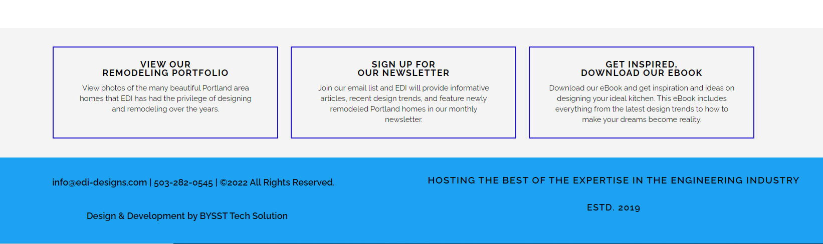

1. VIEW OUR PORTFOLIO - (Text - View Photos of beautiful buildings and homes that EDI has had the privilege of designing over the years.)
2. SIGN UP FOR OUR NEWSLETTER - Replace this with MEET OUR TEAM and a link to that page. ( Text - Meet the expertise in various sectors to enhance the experience of all around Design )
3. GET INSPIRED , DOWNLOAD OUR EBOOK - Replace with CUSTOMIZE YOUR OWN and link to the dedicated tab. ( Text - For the first time in Nepal , Customize and select the materials that you want to use for your building construction )

[info@edi-designs.com](mailto:info@edi-designs.com) | +977-9852074007 | ©2022 EDI All Rights Reserved.  
Powered by BYSST Tech Solution

YOU HAVE REMOVED ALL THE BUTTONS from the home page left side , I SAID only the Twitter and Pinterest Handle to be removed , add the remaining ones.

SCHEDULE A CONSULTATION TAB - Please Change the investment range currency to NRs.

PUT THE PHOTOS IN FIRST PAGE ACCORDING TO OUR SERVICES TAB and add a link to each service on clicking the picture. ( 6 pictures and 6 Titles only - Facade Beautification picture will not be there in the first page.

THE TEXT IN PHOTOS WILL HAVE THE SAME HEADINGS AS IN OUR SERVICES TAB.

LOGO SHOULD BE REPLACED BY THE NEW ONE UPLOADED IN DRIVE WITH NAME.  
  
INPLACE OF TEAM PHOTOGRAPH in the HOME PAGE SECTION , Put the Graphics that has been uploaded in the drive.

It should have a form just above where CUSTOMIZE YOUR OWN is written with the following ;

* Select Design Class [ Three-STAR , Five-STAR and Seven-STAR ] from drop down
* Enter your email address -
* Enter your contact number -
* Submit Button [ in Blue theme - default ]

And below the CUSTOMIZE YOUR OWN Segment add a Button [ CUSTOMIZE NOW ] with link to Customize TAB.